## IT20649562- Lab 5

7. total number of boxes = 19 * 19 * 5 (no of anchor boxes)  
 = 1785

The boxes will be filtered using a 0.6 threshold value. 1783 boxes will still be there after the filter is applied.  
So maximum number is 1785

8. Improved object detection  
 Improves the accuracy of object localization  
 Effectively capture small and large objects within same grid cell.

9. 

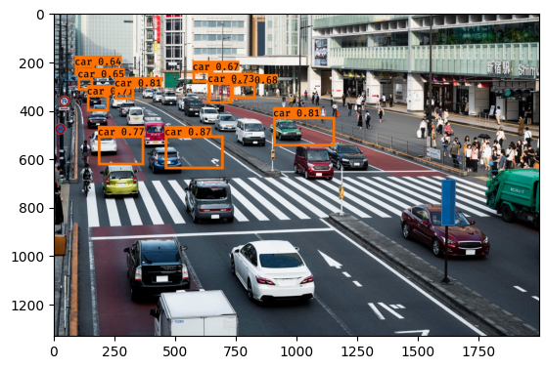

10. Detected the fire hyd and the car correctly. But it has not detected the colour lights and vehicles.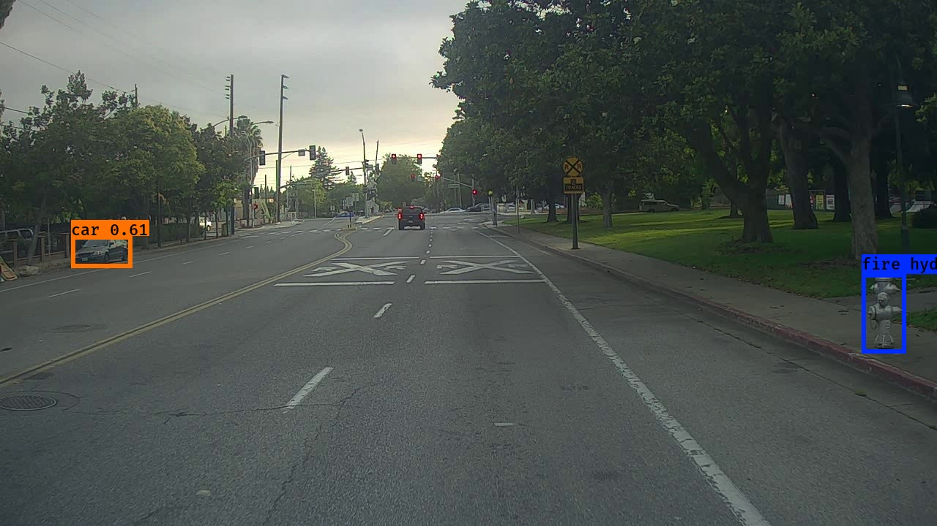

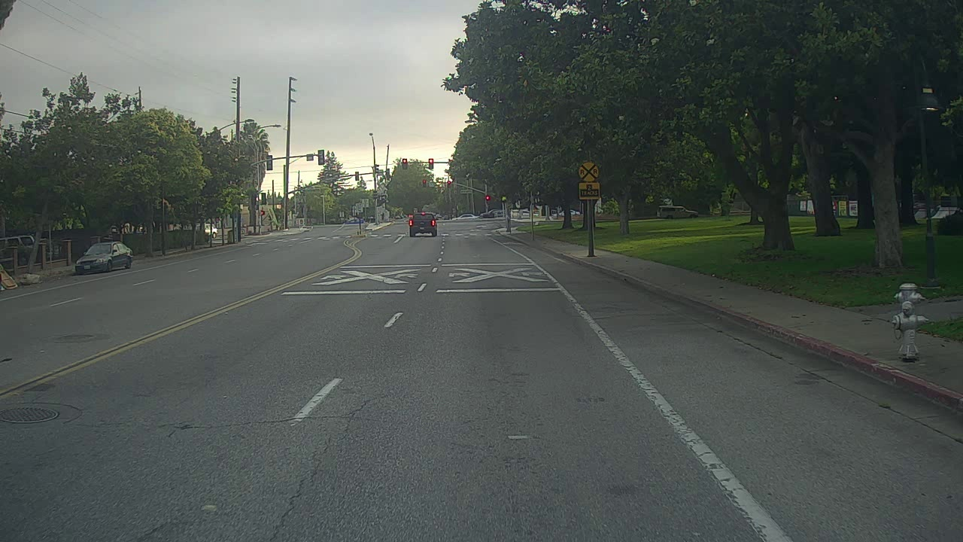

Detected the color light and the car correctly. But it has not detected the other color lights and vehicles  
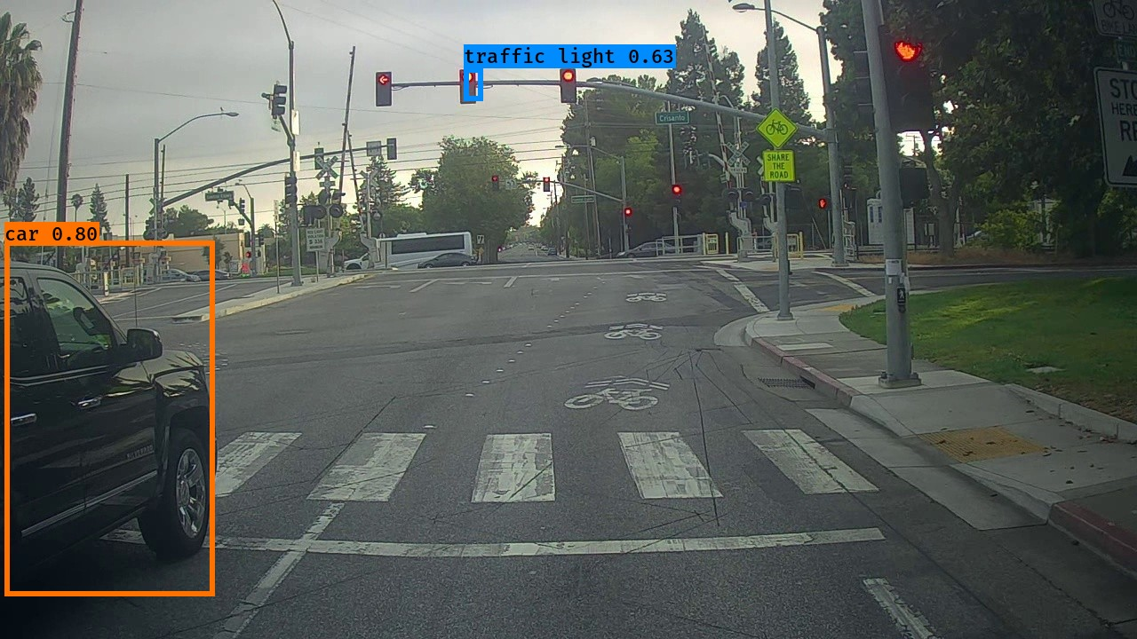

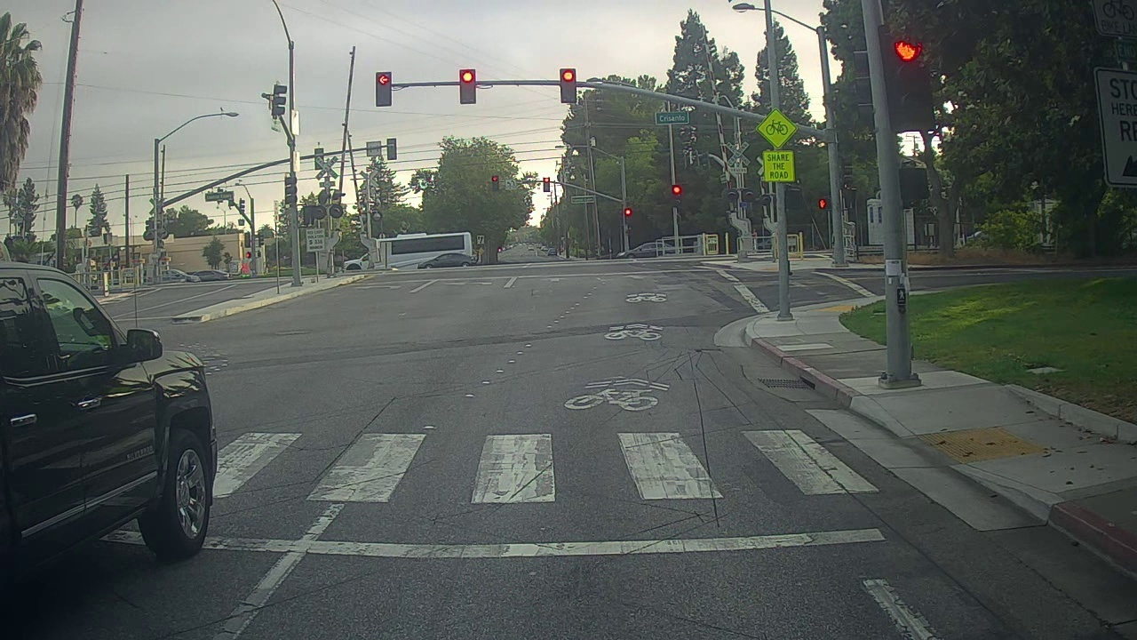

11. Increased and decreased the values for max_boxes, Secure_threshold, Iou_threshold. But couldn’t find any improvements.